Map of Customer Needs
eEurope 2005 — Commentary and Outline from the Viewpoint of an Everyday User

Marja-Liisa VIHERÄ¹, Leena VIUKARI²
¹TeliaSonera Finland Oyj, Elimäenkatu 10, Helsinki, FIN-00051,Finland
Tel: +35820405876, Fax: + 358204063545, Email: Marja-Liisa.Vihera@teliasonera.com
²TeliaSonera Finland Oyj, Elimäenkatu 10, Helsinki, FIN-00051, Finland
Tel: +358204058486, Fax: + 358204063545, Email: Leena.Viukari@teliasonera.com

Abstract: Utilisation of ICT (Information and Communication Technology) requires that the user has access (hardware, software and network connection), skills and motivation. There are many ICT applications that are not being used even though they would clearly improve quality of life. Often, the reason for this is simply that neither the developers nor the users of ICT applications fully understand their potential. The need for using this technology is sometimes decided on the basis of its availability. The objective of this article is to increase understanding of the subject by analysing the use of ICT from the perspective of need (motivation). Based on our observations while working in a telecommunications company, we have divided the use of ICT into seven areas: Communication, Own Production/Self-Expression, Search for Information, Personal Business, Information and Process Systems, Mass Media and Media Culture. We will focus on the affordance [1] of the applications of the technology in each area and make recommendations for continuing the discussion.

1. Introduction
When discussing the utilisation of ICT in society in general, businesses and citizens’ everyday life, each participant in the discussion presents the issues from his/her own point of view: they may want to enhance public administration, or improve the services by which people can search and access information, or develop multimedia content, or seek ways of better presenting their case. Some may wonder about how to order books from a library or what is the importance of games or what is the potential of multimedia in marketing. All these people use the same words but mean different things. One forum for discussion is the eEurope 2005 Action Plan. It has ambitious objectives, and IT applications are expected to promote progress in all areas of life. The action plan also expects that information technology will create new jobs, reform public services and boost productivity in Europe. In order to succeed in all this, we must considerably improve our understanding of the need for using technology.
The use of communication technology is possible if the person has access, skills and motivation [2]. Until now, too much attention has been paid to access, such as the number of broadband and other Internet connections and very little attention has been focussed on analysing the users’ motivation for accessing the Internet, for example. However, the most common reason for not using ICT is the fact that people feel no need for it. If too little attention is paid to analysing the needs and clarifying the concepts, the developers and users of technology cannot have a comprehensible dialogue, and too many good opportunities are missed. For example, when discussing content production, we talk about games, banking services, own photographs, registers, etc, simultaneously in the same context even though people have totally different motivations for creating content in these areas. The external features of technology (hardware) may look the same even if the internal features (software) are rather different.

2. Objective
The objective of this article is to analyse the areas of ICT utilisation from the perspective of need. We will look at the matter from the perspective of the buyer of this technology and its applications, i.e. the customer. The customer may equally well be a company or a private person. Based on our observations while working in a telecommunications company, we have divided the use of ICT into seven areas: Communication, Own Production/Self-Expression, Search for Information, Personal Business, Information and Process Systems, Mass Media and Media Culture. [3]
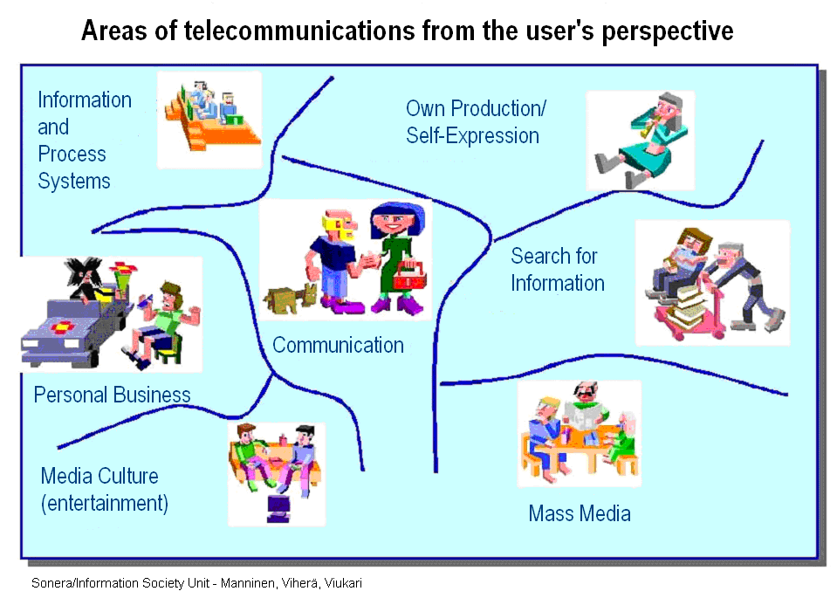Figure 1. Areas of telecommunications from the user’s perspective

According to the eEurope 2005 action plan, Europe should have public real-time services in the fields of healthcare, education, administration and a dynamic e-business environment. In all these areas, we need ICT in many different ways. We shall look at these different ways illustrated in Figure 1. As an example, there are many types of users and uses in the fields of healthcare and public administration.
A more detailed in-depth survey of needs will help us improve both product development and marketing, thus eliminating the obstacles to deploying information technology.

3. Method
The applied method is soft system analysis, originally developed in 1985 and further developed in the early 1990s by Peter Checkland. [4]. The method is applied to researching the future — the precise perspective used in this article also — to combine the goals, visions and perception of the present status of different decision-makers.
The system can be defined in many different ways. The system consists of several sub-systems which all contain their specific functions. We shall analyse the areas of telecommunications as a system consisting of seven sub-systems — which can be further divided into several additional sub-systems. There are different anticipations and functional connections between these sub-systems. Hence, the entire system is more than just a sum total of its parts. [5] However, sub-systems are clearly different with regard to various factors such as skills, motivation, legislation, professional approach, etc.
Checkland (1985) and Mannermaa (2003) [6] show that man-made systems develop through evolution into increasingly complex entities. This applies to social change in particular. Technical innovations, for example, always require a social innovation as well. When these occur simultaneously, it is difficult to differentiate between causes and consequences. When processes catalysed by ICT occur simultaneously in different fields, it is increasingly important to get a grasp of the development in progress and to understand the original objectives as well as new ones, etc.
The problem is how to control the system and how to control the change. We have created our model in order to better understand the system of ICT utilisation and in order to create a genuine dialogue between the customer and the supplier. In particular, soft system analysis lends itself for use in situations where the administration of the system (organisation, combination, co-operation, networking, etc.) is getting out of hand due to a rapidly changing environment or new information. In such situations, it is usual that there is uncertainty within the system — in this case among the operators providing the ICT services — as to how to control the situation and which functions and actions are required. Such a situation will also develop when major innovations occur in the system, resulting in changed methods of operation.
Even though the situation is seen as problematic, people are nevertheless unable to see the exact nature of these problems. Here, soft system analysis helps by dividing problems into sub-problems in order to allow one to decide exactly which operational models, practices and processes are required. It is easier to prepare a strategy step by step for solving parts of problems rather than trying to solve the problems of the whole system.
The model (in Figure 1) helps understand the use of ICT and allows the correct targeting of problem-solving actions. The reliability and validity of the model will be decided when it is put to practical use.
The structure of the model is based on thinking, experience, theoretical discussions (doctoral thesis) and practical experimentation, including 18 years of responsibility for a communications camp (the laboratory of futurological research regarding the use of ICT in line with the users’ own objectives). [7]

4. Areas of ICT utilisation
As stated above, we have analysed the utilisation of ICT through three different components: access, skills and motivation. Initially, we focussed mainly on communication and its requirements, a natural choice since we work for a telecommunications operator. However, when discussing communications, it soon leads to the issues of searching and finding information and one’s own production, i.e. how to convey our thoughts to others. At the same time, the general debate on the information society began to include topics such as the availability of public administration services via the Internet, remote shopping, network magazines and the introduction of mass media into mobile terminal devices, not to mention the media culture, games and downloading music. In nearly all the latter cases, the operations were those of companies or organisations that were either changing their services into self-service operations or increasing their sales, or creating new or revised content for sale through networks. In this discussion the user, the customer, is often forgotten as is the people’s need to communicate and send messages, to be active citizens. We are confident that our analysis will help highlight the key questions from the citizens’ point of view: who is the actor, who is the subject and who is the object in this system?
In our analysis, we will adhere to the access-skills-motivation categorisation because it is valid in all these areas, not merely in communication. We will look at the matter from the perspective of the end-user’s motivation.

User Need | Access/Affordance | Skills | Motivation
Communication | Phone, mobile phone, camera phone, text message, group text message, e-mail, multimedia message, fast message service, phone-circle, etc. | Social, communication and technical competence | To do, to organise and to belong
Own Production and Self-Expression | PC, camera phone, connection to Net, digital video and still camera, text-, photo-, video- and voice process programs, publishing programs, etc. | Both content and technical skills: writing, photographing, editing, publishing, etc. | Self-expression and outsourcing one’s own knowledge
Search for Information | Phone, connection to Internet and search program | Finding information, judging the relevance of the inform,. precision of the information, understanding of the context of the inform. | Learning, working, curiosity, keeping updated, etc.
Personal Business from a Distance, eg. shopping, government services, bank, voting, reclamation, opinion | PC, connection to Internet, mobile phone, text message, GPRS-phone, connection to bank, security services, etc. | Technical skills, knowledge of the security, managing of bank affairs, finding of available services, offering | Efficiency, availability regardless of time and space, convenience
Information and Process System | PC, connection to network, file program, calculation program, security program, etc. | Technical skills, organising skills, filing skills | Efficient and economical  management
Mass Media (Journalism, External Information, Advertising) | TV, radio, Digital TV and radio, Internet newspaper, radio and video, etc. | Installing and using of digi box, installing of channels, media criticism | To enlighten oneself,  To entertain, to keep updated
Media Culture (Games, Material of Education, Media Art, etc.) | Efficient workstations, game program, fast connection to Internet, etc. | Technical skills to play, understanding of logic of games, literature of multimedia | Entertainment, learning

Figure 2. A chart of ICT-related needs

From the perspective of a telecommunications company, the customer in the first three cases is a private person whereas in the latter four cases, the customer is another company, government, third-sector organisation, publisher or production company, etc. The telecommunications company must understand the variety of its customers’ objectives and operations. In the first three cases, we must understand the society, its change and future needs, whereas in the last four cases we must satisfy the needs of our institutional customers. Of course, we must also understand the needs of these customers’ end-users in order to correctly target our services offering. We should also understand the impact that our actions have on the future.
In the following chapter, we will discuss our analysis regarding healthcare, one of the focus areas of the eEurope 2005 action plan.

4.1 Healthcare
The entire health sector, patients, hospitals, nurses, doctors, cleaning staff, attendants, administrative staff, etc., all need and utilise information technology in all seven areas, albeit that different persons utilise it in different areas. This is the essence of the matter: the decisions regarding IT-related purchases are often made exclusively from the perspective of IT administration and only hearing part of the users even though the diverse applications and uses would require each user to be heard and his/her needs to be understood.
People working in the healthcare sector constantly need communication links for discussions with patients, their families, colleagues, etc. Modern technology provides many opportunities for developing the communications culture, for example in cases where members of the patient’s family live in different parts of the world, yet they can all join in the telephone conversation during visiting hours. In this way, the patient will not feel abandoned.
The doctors’ own production is an essential element of their work. Case histories can be produced in different ways, using photographs, X-rays, moving images, text, databases containing measured readings, etc. Likewise, the doctors’ own experiences and research results can be presented in many different ways. The doctor can, for example, record his/her instructions during the patient’s visit, tailor existing instructions to suit that particular patient, and the patient can listen to the CD or other record at home, or check the instructions and background information from the Internet. The possibilities are almost endless.
All actors in the healthcare sector need data banks and have to search for and find information. A network of specialists is also an important source of information for its members who often urgently need very detailed and intricate information. Dealing with health-related personal affairs at a distance requires an understanding of where this method is best applied. Virtual queuing, for example, may be a welcome feature for many patients, and it is relatively easy to implement. A telephonic contact is often preferable to an Internet contact in health-related matters: phones are more readily at hand, and it is easier to explain one’s business verbally. There are telephonic advisory services in Finland where qualified nurses are available for consultancy 24 hours a day. The patient can quickly obtain advice for minor complaints. With the telephonic service, the patient can explain his/her symptoms, and the attending nurse can often judge the seriousness of the situation by the caller’s tone of voice. The service gives its user more confidence than asking for advice via the Internet, and certainly more than reading medical literature/Web doctors’ columns or searching databases for the right answer. In order to do their work well, the nurse attendants need the support of good information services.
Information systems, such as scheduling, logistics systems (pharmaceuticals deliveries, management of bed seats, etc.), administrative systems (billing, stocktaking, payroll, etc), patient information systems, laboratory information systems, X-ray data, pharmaceuticals stocktaking all can be done more effectively using modern technology.
The health sector also needs mass media for marketing and public relations purposes. This can be of particular importance to branches of alternative medicine. Interactive services have an important role in the health sector in ensuring that messages are correctly understood.
Outputs of media culture, where the contents are produced using multimedia methods, are an excellent tool for distributing healthcare information on a CD-Rom or equivalent during surgery hours. This requires that the basic material is already available, and the doctor merely modifies it to suit his/her patient. The patient must also have the necessary equipment and skills for accessing this information. Lack of motivation is unlikely to be a factor.
It should be noted that people who use and develop ICT systems in these seven different areas also represent different professions. They can be professionals searching for information (information specialists), marketing professionals, public relations officers, IT administration professionals, systems analysts developing online services, or professional content producers. Each person must, however, be able to communicate and convey to others their own, even tacit, skills.
Similarly, we can analyse the seven areas from the perspective of an SME business person, individual citizen, eDemocracy, etc.
.

5. Requirements of an information society open for all
The table below is a compilation of certain key factors that are necessary for using and developing ICT applications in different areas.

User Need | Infrastructure | Services | Legislation
Communication | Compatible, open and available telecom networks | Generic multi-channel services (e.g. for the blind and the deaf to communicate with each other) | Communication secrecy laws
Own Production | Compatible mobile and fixed network services | Generic multi-channel services for voice, images, moving pictures.  Server services | Protection of privacy and copyright
Search for Information | Library network, library services and telecom network.  Open information and data systems. | Information services also by phone, text messages and e-mail | Laws concerning availability of information
Personal Business from a Distance | Internet access, mobile connections, connections to the bank, etc. | Diversify and availability of generic services (also for micro-enterprises).  Network partner service. Call centres. | Laws pertaining to secrecy of information
Information and Process System | Compatibility of different systems | Extensive range of services, also those for micro-enterprises, NGOs | Laws pertaining to information security
Mass Media (Journalism, Advertising etc.) | Digital TV and radio network,  Broadband connections | Production of content | Laws pertaining to mass media
Media Culture (Games, Material of Education, Media Art, etc.) | Efficient broadband networks | Production of content | Copyright

Figure 3. Requirements for ICT utilisation
The information society is not possible without an advanced and dynamic infrastructure. In addition to infrastructure, the information society also needs active and skilful members, both individual and corporate. According to statistical information compiled in Finland, 80% of citizens prefer the Internet to the phone as a tool for carrying out private business [8]. This shows that we need different interfaces to information systems, such as telephonic service centres and network partners who in turn must have access to good information systems. The creation of a good, balanced information society that can be shared by all requires that the present structures undergo a profound change. [9]

6. Summary
In Finland, the public debate has often considered broadband connections to equal information society. Our analysis shows that broadband is only important in two areas: Media Culture and Own Production. Hardly any attention has been paid to Own Production in this regard. It seems that broadband networks are primarily being built for receiving the productions of media culture and music from overseas. It is unlikely that any demand for domestic media culture will develop unless people learn to create their own content. The issue is an analogy to writing skills; only when you learn to write will you be able to understand what you read and demand better “literature”, i.e. better texts, and appreciate them. It currently seems that people are primarily seen as objects using material and services produced by others rather than as subjects who make their own contribution to the common intellect of society. Only when this happens will we be able to utilise the best and unprecedented potential of information networks: Every one of us could be a writer, illustrator or producer of our own content, without any censorship or gatekeepers, an elite that would dictate what can be said or depicted. Here, one must not forget the legal requirements regarding protection of privacy or copyright. However, every one of us has an irrevocable right to self-expression without hurting anyone else, and technology now provides extensive possibilities for this.
The creation of a new living and working environment for everybody will require that particular attention is also paid to services for small businesses by developing technology so that it creates a more even playing field in comparison with major companies. These services will not be created on the terms of market forces alone, because small companies cannot possibly develop such services themselves. It is also impossible for micro-enterprises to carry out all necessary background work, to learn the different applications of the latest technology and to deploy it fully. They simply do not have enough time. We also need new job descriptions, such as network secretaries to look after the administrative, marketing and information retrieval services for micro-enterprises. [10]
The applied technology need not always be the very latest; even old technology can have new applications. We need better understanding of people’s everyday needs in order to create new applications. For example, the Helsinki City Library has a service that answers questions sent by the public using all possible channels, such as e-mail, text messages and telephone [11]. Surveys indicate that loneliness is the biggest problem for elderly people in Finland. The telephone conferencing services available in the fixed-line telephone network allow the setting up of discussion groups for any purpose. This allows people living in distant locations or having limited mobility to establish contacts with other people. The small-scale pilot scheme in the city of Heinola showed this to be a meaningful service [12]. We need much more understanding regarding people’s needs for utilising technology and regarding the types of services, technical infrastructure and legislation that are required for building an open and balanced information society. Such information can be obtained using, for example, the tools of future research. When we better understand the needs of different users, technology can be designed to better respond to people’s needs, and marketing can be enhanced. These means would allow better utilisation of the untapped potential of ICT.

References
[1] Affordance is a concept: …it implies that the “values” and “meanings” of things in the environment can be directly perceived. Moreover, it would explain the sense in which values and meanings are external to the perceiver.” J. J. Gibson: The Ecological Approach to Visual Perception, 1979.
http://web.sfc.keio.ac.jp/~masanao/affordance/home.html
[2] Viherä, M.-L. (1999): Ihminen tietoyhteiskunnassa. Kansalaisten viestintävalmiudet kansa-laisyhteiskunnan mahdollistajana. ISBN 951-738-938-8, Turun kauppakorkeakoulu.
Summary in English: People in Information Society – The Citizens’ Communication Skills and the Opening of New Prospects for the Civil Society
[3] Nurmela, J., Alanen, A., Tanskanen, E., Sirkiä, T. and Viherä, M.-L. (2004): eCitizenship Final Report (pp. 21-26), Deliverable D 5.7.4, NEsis, IST – 2000 – 3118.
[4] Checkland, P. (1985): Systems Thinking, Systems Practice. John Wiley & Sons, Pitman Press. Bath Avon.
[5] Rubin, A. (2002): The Soft System Methodology in future Research
http://www.metodix.com/showres.dll/fi/index
[6] Mannermaa, M. (1993): Pehmeä systeemimetodologia evolutionaarisessa tulevaisuudentutkimuksessa. Kirjassa Vapaavuori, Matti (toim.): Miten tutkimme tulevaisuutta? Acta Futura Fennica No. 5, Painatuskeskus, Helsinki.
[7] http://www.viekas.fi/english.html
[8] Nurmela, J. and Ylitalo, M. (2003): The Evolution of the Information Society, Statistics Finland, Helsinki ISBN 952-467-215-4.
[9] Heinone, S., Hietanen, O., Manninen, J., Suvinen, N. and Viherä, M.-L. (2003): Digital balance and services bridging up old and new technology and services, Finland Futures Research Centre, VTT Building and Transport, TeliaSonera Oyj, Helsinki (Finnish only).
[10] http://www.moniverso.fi/
[11] http://igs.kirjastot.fi/index3.html
[12] Haanpää, E. and Viherä, M.-L. (2003): Phone-Circle as a Catalyst for Social Capital, Sonera Information Society Unit, Series 1/2003 (Finnish only), ISBN 952-5187-24-1.

